### **ITUX5.210 UX AND UI FUNDAMENTALS**

*Part One - Report*

*Group Members:  
  
Terrence Charamba – S1  
Artem Hrytsenko – S2  
Rhys Bates – S3*

Contents

**ITUX5.210 UX AND UI FUNDAMENTALS** 0

Introduction 2

Overview of Proposed System (Group Decision) 2

System Requirements – Functional and Non-Functional (Group Decision) 2

Functional: 3

S1 – Terrence – 1: 3

S1 – 2: 3

S1 – 3: 3

S2 – Artem – 1: 3

S2 – 2: 3

S2 – 3: 3

S3 – Rhys – 1: 3

S3 – 2: 3

S3 – 3: 3

Non-Functional: 3

S1 – Terrence – 1: 3

S1 – 2: 3

S1 – 3: 3

S2 – Artem – 1: 3

S2 – 2: 3

S2 – 3: 3

S3 – Rhys – 1: 3

S3 – 2: 3

S3 – 3: 3

Design Thinking (Individual) 4

S1 – Terrence – 4

S2 – Artem – 4

S3 – Rhys – 4

Privacy Evaluation (Group) 4

Initial Designs, Incorporating HTA (Individual and Group) 4

S1 – Terrence –****Decide on a portion of the app to describe/wireframe 5

S2 – Artem – ****Decide on a portion of the app to describe/wireframe 5

S3 – Rhys – ****Decide on a portion of the app to describe/wireframe 5

S1,2,3 – Group – ****Decide on a portion of the app to describe/wireframe 5

Development of Proposed Design Concepts (Individual) 5

Parallel Designs, Finalized (Group) 5

Evaluation of Similar Systems (Individual) 6

Conclusion 6

# Introduction

DOCUMENT REQUIREMENTS OVERVIEW:

<https://learning.eit.ac.nz/pluginfile.php/3909222/mod_resource/content/16/5.210%20UXUI%20Assignment%202024.pdf>

SUPPORTING DOCUMENTATION: (Example submissions)

<https://learning.eit.ac.nz/pluginfile.php/3909230/mod_resource/content/12/ITUX5.210%20-%20Example%20Report.pdf>

<https://learning.eit.ac.nz/pluginfile.php/3909231/mod_resource/content/12/Example%20UXUI%20Level%205%20Project.pdf>

See below for an example introduction:

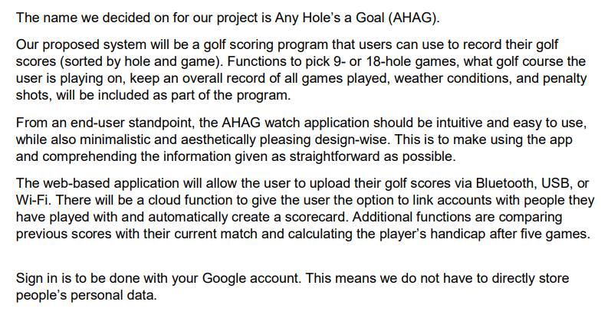

# Overview of Proposed System (Group Decision)



# System Requirements – Functional and Non-Functional (Group Decision)



## Functional:

### S1 – Terrence – 1:

### S1 – 2:

### S1 – 3:

### S2 – Artem – 1:

### S2 – 2:

### S2 – 3:

### S3 – Rhys – 1:

### S3 – 2:

### S3 – 3:

## Non-Functional:

### S1 – Terrence – 1:

### S1 – 2:

### S1 – 3:

### S2 – Artem – 1:

### S2 – 2:

### S2 – 3:

### S3 – Rhys – 1:

### S3 – 2:

### S3 – 3:

# Design Thinking (Individual)

## S1 – Terrence –

## S2 – Artem –

## S3 – Rhys –

See below for an example

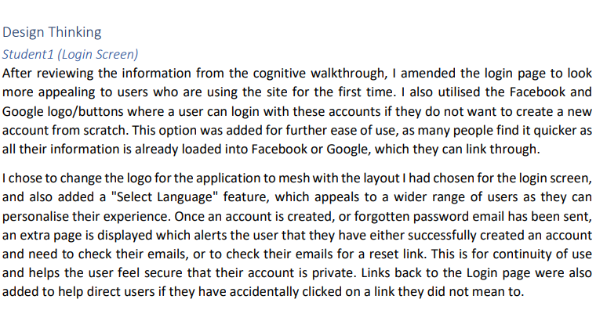

# Privacy Evaluation (Group)



# Initial Designs, Incorporating HTA (Individual and Group)

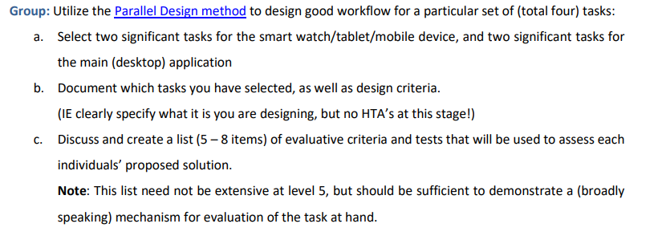

## S1 – Terrence –****Decide on a portion of the app to describe/wireframe

## S2 – Artem – ****Decide on a portion of the app to describe/wireframe

## S3 – Rhys – ****Decide on a portion of the app to describe/wireframe

## S1,2,3 – Group – ****Decide on a portion of the app to describe/wireframe

# Development of Proposed Design Concepts (Individual)

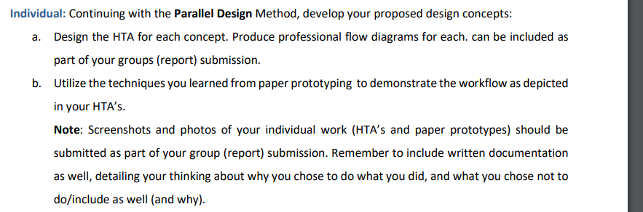

# Parallel Designs, Finalized (Group)

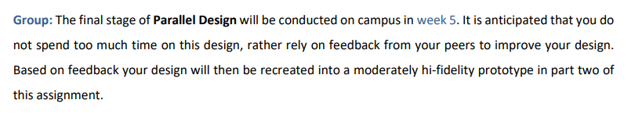

# Evaluation of Similar Systems (Individual)

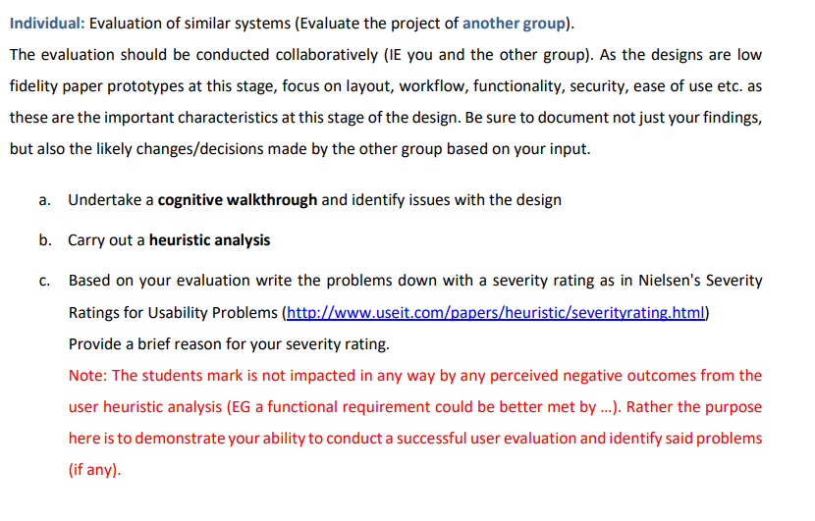

# Conclusion

See below for an example

